# [**PreArm: check firmware or FRAME_CLASS from build**](https://discuss.ardupilot.org/t/prearm-check-firmware-or-frame-class-from-build/40703)

* Changed Frame_Class parameter to 1 (quadcopter)

**Completed full build (lacking telemetry module for now, waiting on Amazon)**

* Used hair tie to position RPi up front
  + Not ideal, waiting on a proper strap or zip ties
* Glued GPS up front on top
* Space for battery on top
* Plug in battery, then usb to mission planner
  + Other order gives Check BRD_TYPE error with barometer
* Callibrated accel, compass, ESCs
* Tried arming, got “Throttle below failsafe” error
  + Failsafe used if transmitter is loses connection with quad, can be used to automatically land, RTL, or others
  + Disabled failsafe
    - May want to use failsafe in the future, but for now, not using a transmitter
  + Failsafe Documentation: <https://ardupilot.org/copter/docs/radio-failsafe.html>
* Arm motors through MP
  + Error Radio Failsafe On
  + Error Logging failed
  + Can force arming here
  + Arming runs motors at a moderate low speed
* Run motor test through ardupilot… All motors spin in the same direction
  + Motors miss-labeled? A and B across from eachother, C and D across from eachother
  + Proper motor labeling: [https://ardupilot.org/copter/docs/connect-escs-and-motors.html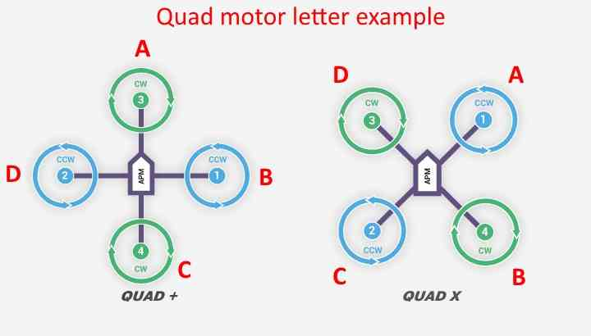](https://ardupilot.org/copter/docs/connect-escs-and-motors.html#)
  + Consulted r/multicopter, hopefully they can help
  + **FIXED:**
    - Can change pin labeling with SERIALn_FUNCTION parameters
    - SERIAL1_FUNCTION controls the function of serial pin 1
    - Swapped functions of S1 and S3 to get it properly labeled
* Tail believes it is nose and vice versa
  + Rotating compass yaw does nothing
  + Recalibrating accelerometer does nothing
  + Board orientation can be fixed by flipping the FC around
  + **FIXED:**
    - Changed parameter AHRS_ORIENTATION to yaw180